Bash script

TASK 1

1. create file print.sh
# create shell script:
input: USERNAME.
Operation: concatenation Hello <username>
output: Hello <username>
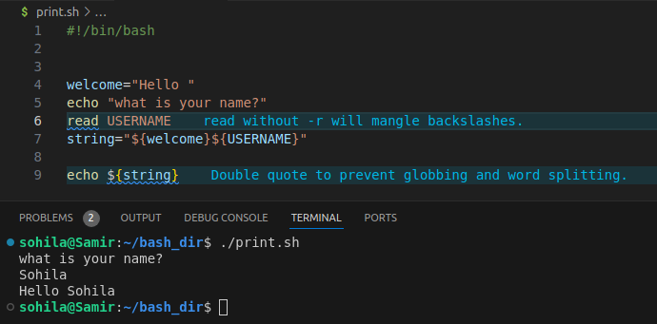
TASK 2

1. create file path.sh
#create shell script:
input: /home/file.txt
Operation: fileName: file
ext: .txt
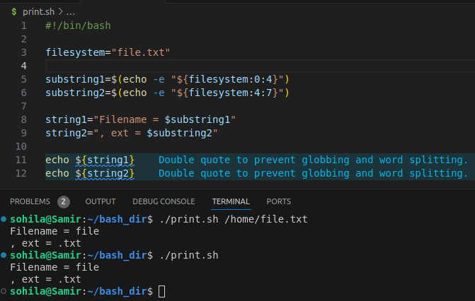
output: Filename = file, ext = .txt

TASK 3

Requirements for Shell Scripts
Performing Integer Operations
Script Name: add_integers.sh

Function: Adds two integers.
Input: Two integers passed as arguments.
Validation:
Ensure exactly two arguments are passed.
Ensure both arguments are valid integers.
If validation fails, output an error message and exist.
Operation: Calculate the sum of the two integers.
Output: Display the sum.

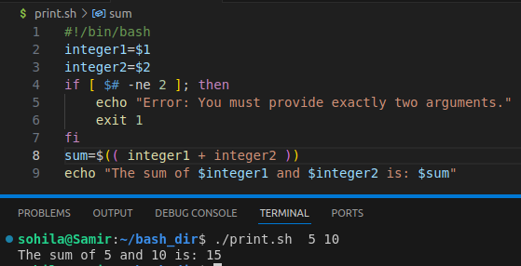

TASK 4

Requirements for Shell Scripts:
Performing Integer Operation
Script Name: simple_cal.sh
1. Ask user first number.
2. Ask user second number.
3. Ask user user operation.
4. based on operation ---> result.
Output: Display the result.
